Programming Fundamentals

**Lab Assignments (2ND Semester)**

## Name: Hamza Kamelen

# Roll No: 22F-BSAI-09

# Dept: Artificial Intelligence

### LAB 01

**Code:**

// BIO DATA

    printf("--------------Bio Data------------------ \n");

printf("Hamza Kamelen");

    printf("\n 22F-BSAI-09");

    printf("\n Student of DUET");

**Output:**

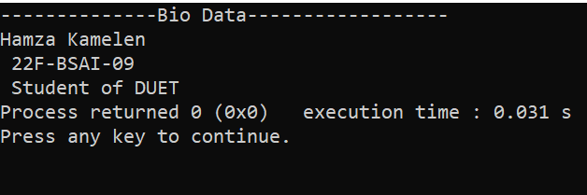

**Code:**

// Stair Case

    printf(":______ \n");

    printf("\t:______ \n");

    printf("\t\t:______ \n");

    printf("\t\t\t:______ \n");

    printf("\t\t\t\t:______ \n");

    printf("\t\t\t\t\t:______ \n");

**Output:**

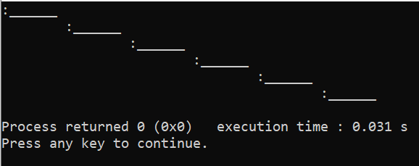

**-------------------------------------------------------------**

### LAB 02

**Code:**

/*Task 01:

Using scanf() and printf(),Create a program with the help of format specifiers to print your marks

Marks of Subject 1 Grad of Subject 1

------------------------------------------------ */

 int MarksEnglish ,MarksMath,MarksUrdu,Obtained,percentage;

 printf("\nMarks of English out of 100:--");

 scanf("%d",&MarksEnglish);

 printf("Marks of English %d",MarksEnglish);

 printf("\nMarks of Math out of 100:--");

 scanf("%d",&MarksMath);

 printf("\nMarks of Math %d",MarksMath);

 printf("\nMarks of Urdu out of 100:--");

 scanf("%d",&MarksUrdu);

 printf("\nMarks of Urdu %d",MarksUrdu);

 Obtained= MarksEnglish+MarksMath+MarksUrdu;

 printf("\nObtained Marks %d",Obtained);

 percentage= (Obtained*100/300);

 printf("\nYour Percentage is %d \n",percentage);

 if(percentage > 50){

     printf("Your Grade is A");

 }else{

     printf("Your Grade is B");

 }

**Output:**

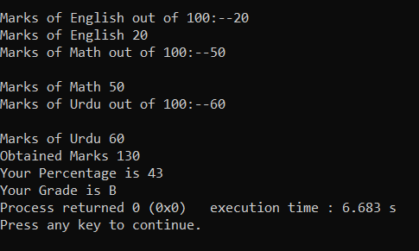

**Code:**

//Task02:

Using scanf() and printf()Create a program that has the following output: (the price should be taken as input from the user)

//Price of one page:    4.75 Rs

//Price of 15 pages:    71.25 Rs

//Price after discount: 60.00 Rs

int Price;

int FifteenPrice ,DisPrice;

printf("Price of one page:-");

scanf("%d",&Price);

printf("\n Price of one page %d",Price);

FifteenPrice = Price*15;

printf("\n Price of 15 page %d",FifteenPrice);

DisPrice = FifteenPrice - 10%

printf("\n Disc Price %d",DisPrice);

**Output:**

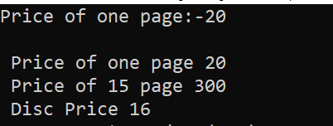

**Code:**

//Task 03:

Write a program that can print a table of 9

printf("\tMultiplication Table of 9\n\n");

   printf("===================================================\n");

    int num = 9;

    int i;

    printf("Multiplication table of %d:\n", num);

    for (i = 1; i <= 10; i++) {

        printf("%d x %d = %d\n", num, i, num * i);

    }

**Output:**

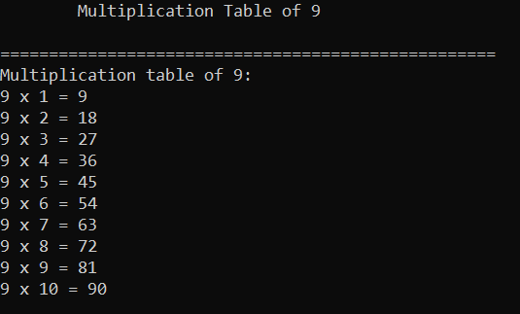

**Code:**

//Task 05:

Take two integers as input from the user and swap the values.

int num1, num2;

int swap;

printf("Enter First Number");

scanf("%d",&num1);

printf("\nEnter Second Number");

scanf("%d",&num2);

printf("Before Swap \n First Int %d , \n Second Int: %d",num1,num2);

swap = num1;

num1 = num2;

num2 = swap;

printf("\n After Swap \n First Int %d , \n Second Int: %d",num1,num2);

**Output:**

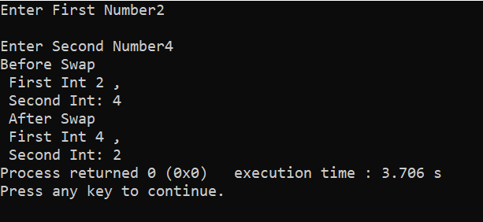

**Code:**

/*Task 06:

Using scanf() and Constant, create a program who takes an input which is radius of circle and calculate area of it. Area of Circle 𝐴 = 𝜋 𝑟2 where 𝜋 is constant (3.1415)*/

    printf("---------------Area of Circle-----------------");

    int radius, Area;

    const Pie = 3.142;

    printf("\nPlease Enter Radius");

    scanf("%d", &radius);

    Area = Pie * (radius * radius);

    printf("\nArea == %d", Area);

**Output:**

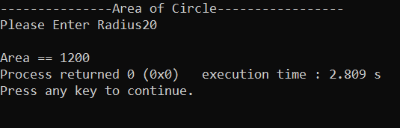

**Code:**

// Task 07:

Create a program that takes a decimal number from user and displays the whole number part and fraction part of the number separately

    float Numb;

    int whole;

    float frac;

    printf("Please Write Decimal Number");

    scanf("%f", &Numb);

    printf("\nYour Number is %f", Numb);

    whole = Numb;

    printf("\n---------Whole Number is %d", whole);

    frac = Numb - whole;

    printf("\n---------Fraction Number is %f", frac);

**Output:**

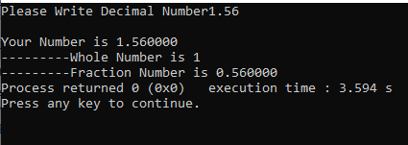

**-------------------------------------------------------------**

### LAB 03

**Code:**

//-------------TASK-01: Marksheet----------*

    printf("------------SUBJECT MARKSHEET----------");

    int English, Urdu, Math, Islamiat, Computer;

    printf("\nPlease Enter English Marks");

    scanf("\n %d", &English);

    printf("\nPlease Enter Urdu Marks");

    scanf("\n %d", &Urdu);

    printf("\nPlease Enter Math Marks");

    scanf("\n %d", &Math);

    printf("\nPlease Enter Islamiat Marks");

    scanf("\n %d", &Islamiat);

    printf("\nPlease Enter Computer Marks");

    scanf("\n %d", &Computer);

    int total = 500;

    int Obtained = English + Urdu + Math + Islamiat + Computer;

    float percentage = Obtained * 100 / total;

    printf("\n\tEnglish: %d \n\tUrdu: %d \n\tMath: %d

\n\tIslamiat: %d  \n\tComputer: %d \n\n\t Obtained: %d \n

\n\t Total: %d \n\n\t Percentage: %f", English, Urdu, Math,

Islamiat, Computer, Obtained, total, percentage);

**Output:**

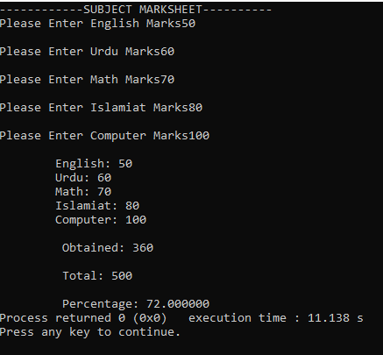

**-------------------------------------------------------------**

### LAB 05

**Code:**

  // DUET Grading System

MArks Input dena h wo Program marks ko dekh kr Humara grade or CGPA dekhae

    int Marks;

    printf("\t\t\tPlease Enter Your PF MARKS And CHECK CGPA");

    scanf("%d", &Marks);

    printf("\t\t\tYour PF MARKS is: %d", Marks);

    if (Marks >= 85)

    {

        if (Marks > 100)

        {

            printf("\t\t You Are Robot? \n Please Enter Correct Marks");

        }

        else

        {

            printf("\t\tGrade: A+ \n\t\t\t\tCGPA:4.0");

        }

    }

    else if (Marks >= 80 && Marks <= 84)

    {

        printf("\t\tGrade: A \n\t\t\t\tCGPA:3.7");

    }

    else if (Marks >= 75 && Marks <= 79)

    {

        printf("\t\tGrade: B+ \n\t\t\t\tCGPA:3.5");

    }

    else if (Marks >= 70 && Marks <= 74)

    {

        printf("\t\tGrade: B \n\t\t\t\tCGPA:3.0");

    }

    else if (Marks >= 65 && Marks <= 69)

    {

        printf("\t\tGrade: C+ \n\t\t\t\tCGPA:2.5");

    }

    else if (Marks >= 60 && Marks <= 64)

    {

        printf("\t\tGrade: C \n\t\t\t\tCGPA:2.0");

    }

    else if (Marks >= 55 && Marks <= 59)

    {

        printf("\t\tGrade: D+ \n\t\t\t\tCGPA:1.5");

    }

    else if (Marks >= 50 && Marks <= 54)

    {

        printf("\t\tGrade: D \n\t\t\t\tCGPA:1.0");

    }

    else

    {

        if (Marks < 1)

        {

            printf("Invalid......!");

        }

        else

        {

            printf("\n\t\t\t\tFAIL!!");

        }

    }

**Output:**

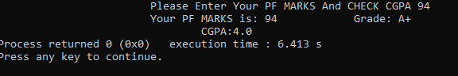

**-------------------------------------------------------------**

### LAB 06

**Code:**

//Task 01: Write a program to print the table till 10 input taken from user

    //======From For Loop======

    int table, num, answer;

    printf("Table of ");

    scanf("%d", &table);

    for (num = 1; num <= 10; num++)

    {

        answer = table * num;

        printf("\n %d x %d = %d", table, num, answer);

    }

    //======From While Loop======

    int i = 1, table, answer;

    printf("Table of ");

    scanf("%d", &table);

    while (i <= 10)

    {

        answer = table * i;

        printf("\n%d x %d = %d", table, i, answer);

        i++;

    }

    //======From Do While Loop======

    int i = 1, table, answer;

    printf("Table of ");

    scanf("%d", &table);

    do

    {

        answer = table * i;

        printf("\n%d x %d = %d", table, i, answer);

        i++;

    } while (i <= 10);

**Output:**

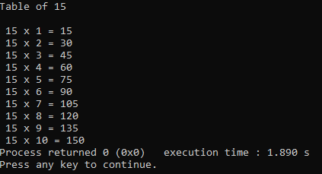

**Code:**

    // Task 02: Write a program that prints the square of the integer taken

as input, until the square is less then 1000

//======From For Loop======

    int squareinp, i;

    printf("print the number which you want to square till 1000: ");

    scanf("%d", &squareinp);

    for (i = 1; squareinp <= 1000; i++)

    {

        squareinp = squareinp * squareinp;

        if (squareinp >= 1000)

        {

            break;

        }

        printf("\n %d Square is %d", i, squareinp);

    }

    //======From While Loop======

    int num;

    printf("Enter a Number ");

    scanf("%d", &num);

    while (num <= 1000)

    {

        num = num * num;

        if (num >= 1000)

        {

            break;

        }

        printf("\n%d", num);

    }

    //======From Do While loop======

    int num;

    printf("Please Enter Number");

    scanf("%d", &num);

    do

    {

        num *= num;

        if (num >= 1000)

        {

            break;

        }

        printf("\n%d", num);

    } while (num <= 1000);

**Output:**

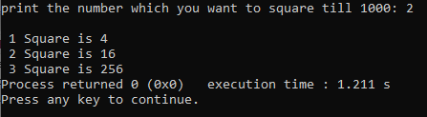

**Code:**

    //Task 04" Write a program that take character input terminate when x

is pressed

    //======From For Loop======

    char userInput;

    int i;

    printf("Lets Begin the Game\n Note:(If you type x or X

program terminate)\n ");

    for (i = 1; i <= 10; i++)

    {

        printf("Please Enter Any Character: ");

        scanf(" %c", &userInput);

        if (userInput == 'x' || userInput == 'X')

        {

            break;

        }

    }

    //======From While loop======

    char Alphabet;

    while (Alphabet != 'x')

    {

        printf("Please Enter Alphabet");

        scanf(" %c", &Alphabet);

        if (Alphabet == 'x' || Alphabet == 'X')

        {

            break;

        }

        printf("\n Your Alphabet is  %c", Alphabet);

    }

    //======From Do While loop======

    char Alphabet;

    do

    {

        printf("\nPlease Enter Alphabet ");

        scanf(" %c", &Alphabet);

        if (Alphabet == 'x' || Alphabet == 'X')

        {

            break;

        }

        printf("\nYour Alphabet is %c", Alphabet);

    }while (Alphabet != 'x');

**Output:**

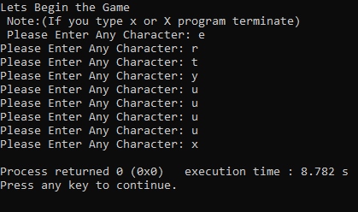

**Code:**

    // Task 05: Write a program that character input unless Enter is pressed and print total no of inputs

    //======From For Loop======

    char userInput;

    int count = 0;

    for (;;)

    {

        printf("\nWrite any Character: ");

        userInput = getchar();

        if (userInput == '\n')

        {

            break;

        }

        count++;

    }

    printf("Your Counting is %d", count);

    //======From While Loop======

    char ch;

    int count = 0;

    printf("\nPlease Enter Character ");

    while (ch != '\n')

    {

        ch = getchar();

        if (ch == '\n')

        {

            break;

        }

count++;

    }

    printf("Your Count is %d", count);

    //======From Do While Loop======

    char ch;

    int count = 0;

    printf("\nPlease Enter Character ");

    do

    {

        ch = getchar();

        if (ch == '\n')

        {

            break;

        }

        count++;

    } while (ch != '\n');

    printf("Your Count is %d", count);

**Output:**

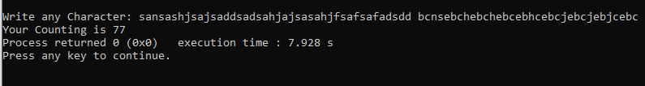

**Code:**

    // Task:05 Write a Series of first 50 odd and even numbers

    //======From For Loop======

    for (i = 1; i <= 50; i++)

    {

        if (i % 2 == 0)

        {

            printf("\nThis number is even %d", i);

        }

        else

        {

            printf("\nThis number is odd %d", i);

        }

    }

    //======From While Loop======

    int i = 1;

    while (i != 50)

    {

        if (i % 2 == 0)

        {

            printf("\nThis number is even %d", i);

            i++;

        }

        else

        {

            printf("\nThis number is odd %d", i);

            i++;

        }

    }

    //======Do While Loop======

    int i = 1;

    do

    {

        if (i % 2 == 0)

        {

            printf("\nThis number is even %d", i);

            i++;

        }

        else

        {

            printf("\nThis number is odd %d", i);

            i++;

        }

    } while (i != 50);

**Output:**

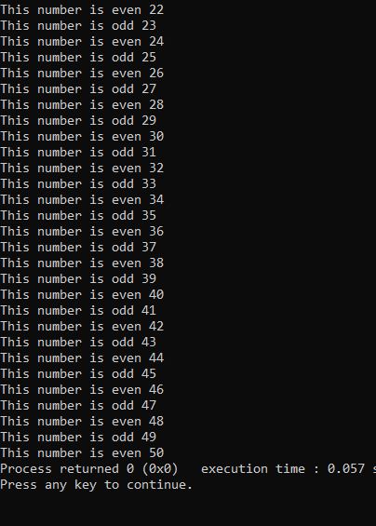

**Code:**

    /*Task 06(1): Print the following series:

    1.  1,2, 3...30*/

    //======From For Loop======

    int i;

    for (i = 1; i <= 30; i++)

    {

        printf("\n%d", i);

    }

//======From While Loop======

    int i = 1;

    while (i <= 30)

    {

        printf("\n%d", i);

        i++;

    }

//======Do While Loop======

int i = 1;

    do

    {

        printf("\n%d", i);

        i++;

    } while (i <= 30);

**Output:**



**Code:**

    // Task06(2): Print the following series:

    2.  1,2,2,3,3,4,4, 5...50

    //======From For Loop======

    int i = 1;

    printf("%d,", i);

    i++;

    for (i; i <= 50; i++)

    {

        printf("%d,", i);

        printf("%d,", i);

    }

    //======From While Loop======

    int i = 1;

    printf("%d", i);

    i++;

    while (i <= 50)

    {

        printf("\n%d", i);

        printf("\n%d", i);

        i++;

    }

    //======Do While Loop======

    int i = 1;

    printf("%d", i);

    i++;

    do

    {

        printf("\n%d", i);

        printf("\n%d", i);

        i++;

    } while (i <= 50);

**Output:**



**Code:**

    // Task06(3): Print the following series: Fibonacci series

    3.   0,1,1,2,3,5,8...100

    // From For Loop

    int n, first = 0, second = 1, next, i;

    printf("No of Terms: ");

    scanf("%d", &n);

    printf("%d, %d, ", first, second);

    // i=3 bcz first two terms written Already

    for (i = 3; i <= n; i++)

    {

        next = first + second;

        if (next <= 100)

        {

      break;

        }

        printf("%d, ", next);

        first = second;

        second = next;

    }

    // From While Loop

    int n, first = 0, second = 1, next, i;

    printf("No of Terms: ");

    scanf("%d", &n);

    printf("%d, %d, ", first, second);

    i = 3; // bcz first two terms written Already

    while (i <= n)

    {

        next = first + second;

        if (next <= 100)

        {

            break;

        }

        printf("%d,", next);

        first = second;

        second = next;

        i++;

    }

    // From Do While Loop

    int n, first = 0, second = 1, next, i;

    printf("No of Terms: ");

    scanf("%d", &n);

    printf("%d, %d, ", first, second);

    i = 3; // bcz first two terms written Already

    do

    {

        next = first + second;

        if (next <= 100)

        { break;

        }

        printf("%d,", next);

        first = second;

        second = next;

        i++;

    } while (i <= n);

**Output:**

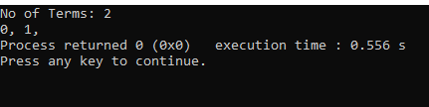

**-------------------------------------------------------------**

### LAB 07

**Code:**

   /*Task 01:

Write a C Program to print half pyramid as using numbers as shown in figure below.

    1

    1 2

    1 2 3

    1 2 3 4

    1 2 3 4 5 */

// From For Loop

    int rows, i, j;

    printf("Enter Rows: ");

    scanf("%d", &rows);

    for (i = 1; i <= rows; i++)

    {

        for (j = 1; j <= i; j++)

        {

            printf("%d ", j);

        }

        printf("\n");

    }

    // From While Loop

    int rows, i, j;

    printf("Enter Rows: ");

    scanf("%d", &rows);

    i = 1;

while (i <= rows)

    {

        j = 1;

        while (j <= i)

        {

            printf("%d ", j);

            j++;

        }

        i++;

        printf("\n");

    }

    // From Do While Loop

    int rows, i, j;

    printf("Enter Rows: ");

    scanf("%d", &rows);

    i = 1;

    do

    {

        j = 1;

        do

        {

            printf("%d ", j);

            j++;

        } while (j <= i);

        i++;

        printf("\n");

    } while (i <= rows);

**Output:**

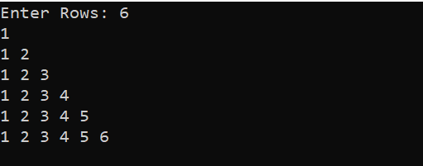

**Code:**

/*Task 02:

Write a C program to print square star (*) pattern series of n rows

For Example: if n=5 the star pattern should be printed like:

    *****

    *****

    *****

    *****

    ***** */

    // From For Loop

    int rows, i, j;

    printf("Enter Rows: ");

    scanf("%d", &rows);

    for (i = 1; i <= rows; i++)

    {

        for (j = 1; j <= rows; j++)

        {

            printf("* ");

        }

        printf("\n");

    }

    // From While Loop

    int rows, i, j;

    printf("Enter Rows: ");

    scanf("%d", &rows);

    i = 1;

    while (i <= rows)

    {

        j = 1;

        while (j <= rows)

        {

            printf("* ");

            j++;

        }

        i++;

        printf("\n");

    }

    // From Do While Loop

    int rows, i, j;

    printf("Enter Rows: ");

    scanf("%d", &rows);

    i = 1;

    do

    {

        j = 1;

        do

        {

            printf("*");

            j++;

        } while (j <= rows);

        i++;

        printf("\n");

    } while (i <= rows);

**Output:**

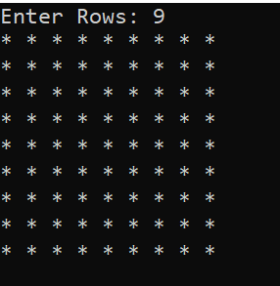

**Code:**

//Task 3: Write a C program to print Fibonacci series up to n terms.

// From For Loop

    int n, first = 0, second = 1, next, i;

printf("No of Terms: ");

    scanf("%d", &n);

    printf("%d, %d, ", first, second);

    // i=3 bcz first two terms written Already

for (i = 3; i <= n; i++)

    {

        next = first + second;

        printf("%d, ", next);

        first = second;

        second = next;

    }

    // From While Loop

    int n, first = 0, second = 1, next, i;

    printf("No of Terms: ");

    scanf("%d", &n);

    printf("%d, %d, ", first, second);

    i = 3; // bcz first two terms written Already

    while (i <= n)

    {

        next = first + second;

        printf("%d,", next);

        first = second;

        second = next;

        i++;

    }

    // From Do While Loop

    int n, first = 0, second = 1, next, i;

    printf("No of Terms: ");

    scanf("%d", &n);

    printf("%d, %d, ", first, second);

    i = 3; // bcz first two terms written Already

    do {

        next = first + second;

        printf("%d,", next);

        first = second;

        second = next;

        i++;

    } while (i <= n);

**Output:**

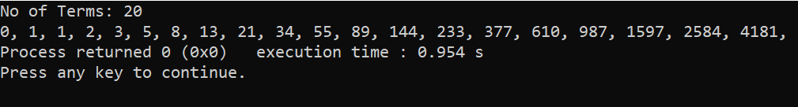

**Code:**

/*Task 4:

    Use for-loop to print the multiplication table below:

    1   2   3   4   5   6   7   8   9

    2   4   6   8   10  12  14  16  18

    3   6   9   12  15  18  21  24  27

    4   8   12  16  20  24  28  32  36

    5   10  15  20  25  30  35  40  45

    6   12  18  24  30  36  42  48  54

    7   14  21  28  35  42  49  56  63

    8   16  24  32  40  48  56  64  72

    9   18  27  36  45  54  63  72  81*/

    // From For Loop

    int rows = 9, cols = 9, i, j;

    printf("Multiplication Table: \n");

    for (i = 1; i <= rows; i++)

    {

        for (j = 1; j <= cols; j++)

        {

            printf("%d\t", i * j);

        }

        printf("\n");

    }

    // From While Loop

    int rows = 9, cols = 9, i, j;

    printf("Multiplication Table: \n");

    i = 1;

    while (i <= rows)

    {

        j = 1;

        while (j <= cols)

        {

            printf("%d\t", i * j);

            j++;

        }

        i++;

        printf("\n");

    }

    // From Do While Loop

    int rows = 9, cols = 9, i, j;

    printf("Multiplication Table: \n");

    i = 1;

    do

    {

        j = 1;

        do

        {

            printf("%d\t", i * j);

            j++;

        } while (j <= cols);

        i++;

        printf("\n");

    } while (i <= rows);

**Output:**

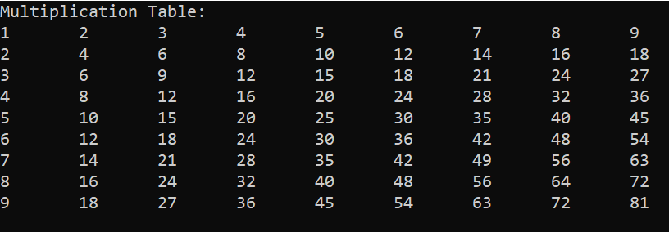

**Code:**

//Task 06: Write a program to print the table till 10 input taken from user

    //======From For Loop======

    int table, num, answer;

    printf("Table of ");

    scanf("%d", &table);

    for (num = 1; num <= 10; num++)

    {

        answer = table * num;

        printf("\n %d x %d = %d", table, num, answer);

    }

    //======From While Loop======

    int i = 1, table, answer;

    printf("Table of ");

    scanf("%d", &table);

    while (i <= 10)

    {

        answer = table * i;

        printf("\n%d x %d = %d", table, i, answer);

        i++;

    }

    //======From Do While Loop======

    int i = 1, table, answer;

    printf("Table of ");

    scanf("%d", &table);

    do

    {

        answer = table * i;

        printf("\n%d x %d = %d", table, i, answer);

        i++;

    } while (i <= 10);

**Output:**

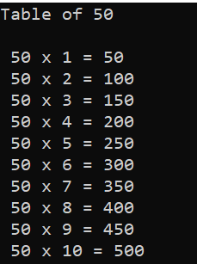

**-------------------------------------------------------------**

### LAB 08

**Code:**

/*Task 1: An electric power distribution company charges its domestic consumers as follows.

    Consumption Units   Rate of Charge

    0-200               Rs.0.50 per unit

    201-400             Rs.100 plus Rs.0.65 per unit excess 200

    401-600             Rs.230 plus Rs.0.80 per unit excess of 400.

    Write a C program that reads the customer number and power consumed and prints the amount to be paid by the customer. The program runs at least once. */

    int customerNo, powerConsumed;

    float amountToPaid;

    printf("=== Welcome ===");

do

    {

        printf("\nEnter Your Customer Number ");

        scanf("%d", &customerNo);

        printf("Enter Power Consumed: ");

        scanf("%d", &powerConsumed);

        printf("Customer No: %d\nAmount to be paid: %d\n",

customerNo, powerConsumed);

        if (powerConsumed <= 200)

        {

            amountToPaid = powerConsumed * 0.50;

        }

        else if (200 < powerConsumed <= 400)

        {

            amountToPaid = 100 + (powerConsumed - 200) * 0.65;

        }

        else if (400 < powerConsumed <= 600)

        {

            amountToPaid = 230 + (powerConsumed - 400) * 0.80;

        }

        else

        {

            amountToPaid = 0;

        }

        if (amountToPaid != 0)

        {

            printf("Customer Number: %d\n", customerNo);

            printf("Amount to be paid: Rs. %.2f\n", amountToPaid);

        }

        else

        {

            printf("Invalid power consumption.\n");

        }

        printf("============================");

    } while (1);

**Output:**

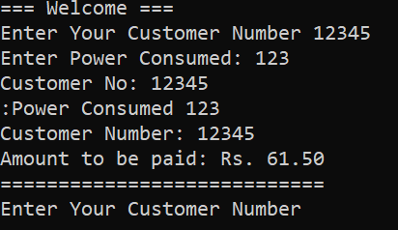

**Code:**

/*Task 2:

Write a C program that allows the user to enter in 5 grades, ie, marks between 0 - 100. The program must calculate  the average mark, and state the number of marks less than 65.*/

int i = 1, marksofSubject[i], total, fail = 0;

float avg;

printf("Enter 5 Subject Marks (0-100)");

printf("\nYou will Fail if you got Less than 65 Marks:");

do

{

    printf("\nEnter %d Subject Marks: ", i);

    scanf("%d", &marksofSubject[i]);

    if (marksofSubject[i] > 100)

    {

        printf("Please Enter Valid Marks");

        break;

    }

    total += marksofSubject[i];

    if (marksofSubject[i] < 65)

    {

        fail++;

    }

    i++;

} while (i <= 5);

if (fail == 0)

{

    printf("\nCongratulations You Passed All Subjects ");

}

else

{

    printf("\nOh! Failed in %d Subjects ", fail);

}

avg = total / 5;

printf("\nYour Total Marks is %d", total);

printf("\nYour Average is %.2f ", avg);

**Output:**

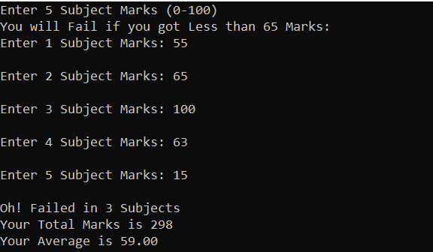

**Code:**

/*Task 3:

Write a program that will generate even numbers and calculate sum and average of those numbers.*/

int sum, i = 1;

float avg;

do

{

    if (i % 2 == 0)

    {

        printf("Even Number %d\n", i);

        sum += i;

    }

    i++;

} while (i <= 300);

avg = sum / i;

printf("Sum: %d\n", sum);

printf("Average: %f", avg);

printf("\n");

**Output:**

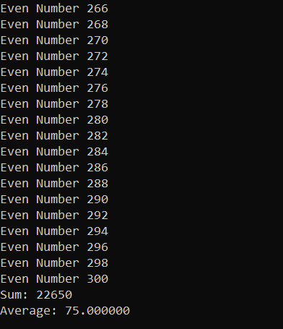

**Code:**

/*Task 4:

Using do while loop, program to show a below multiplication table:

    1   2   3   4   5   6   7   8   9

    2   4   6   8   10  12  14  16  18

    3   6   9   12  15  18  21  24  27

    4   8   12  16  20  24  28  32  36

    5   10  15  20  25  30  35  40  45

    6   12  18  24  30  36  42  48  54

    7   14  21  28  35  42  49  56  63

    8   16  24  32  40  48  56  64  72

    9   18  27  36  45  54  63  72  81 */

printf("Mutiplication Table\n");

int row = 1, col;

do

{

    col = 1;

    do

    {

        printf("%d\t", row * col);

        col++;

    } while (col <= 9);

    printf("\n");

    row++;

} while (row <= 9);

**Output:**

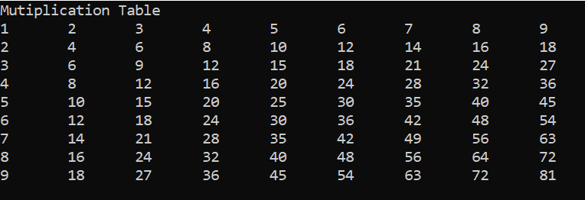

**Code:**

/*Task 5:

Write a program that will generate years from 1950 to 2015 and mention if the year is leap year. */

/*Notes:

A year that is divisible by 4 is a leap year.

However, years divisible by 100 are not leap years, unless...

The year is also divisible by 400, in which case it is a leap year.*/

int year = 1950;

do

{

    if ((year % 4 == 0 && year % 100 != 0) || year % 400 == 0)

    {

        printf("%d is a Leap Year\n", year);

    }

    year++;

} while (year <= 2015);

**Output:**

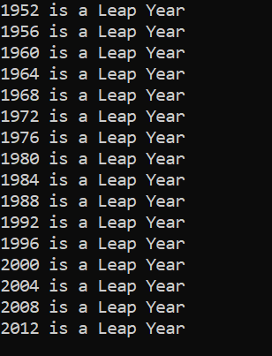

**Code:**

/*Task 6:

Write a program to output a table of values of the integers starting at 1 and their squares. Label the table at the top of the columns. For example, your output might look like this:

                       Number   Square

                       1         1

                       3         9*/

int i = 1;

do

{

    printf("Number: %d\nSquare: %d\n ---------------\n", i, i * i);

    i++;

} while (i <= 50);

**Output:**

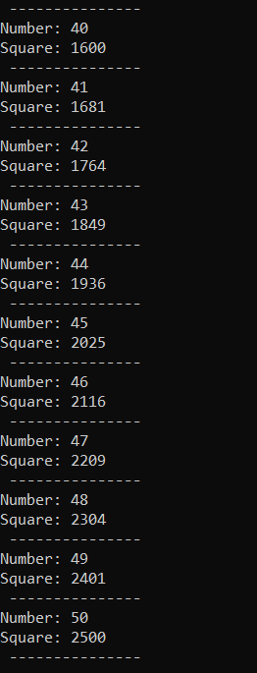

**Code:**

/*Task 7:

Write a program to print all Prime numbers between 1 to 500.

A Prime Number can be divided evenly only by 1, or itself. And it must be a whole number greater than 1.

Example:

5 can only be divided evenly by 1 or 5, so it is a prime number. */

// From For Loop

int count, i, n;

for (n = 1; n <= 500; n++)

{

    count = 0;

    for (i = 1; i <= n; i++)

    {

        if (n % i == 0)

        {

            count++;

        }

    }

    if (count == 2)

    {

        printf("%d is a Prime Number\n", n);

    }

}

// From While loop

int count, n, i;

n = 1;

while (n <= 500)

{

    i = 1;

    count = 0;

    while (i <= n)

    {

        if (n % i == 0)

        {

            count++;

        }

        i++;

    }

    if (count == 2)

    {

        printf("%d is Prime number\n", n);

    }

    n++;

}

// From Do While

int count, n, i;

n = 1;

do

{

    i = 1;

    count = 0;

    do

    {

        if (n % i == 0)

        {

            count++;

        }

        i++;

    } while (i <= n);

    if (count == 2)

    {

        printf("%d is a prime Number\n", n);

    }

    n++;

} while (n <= 500);

**Output:**

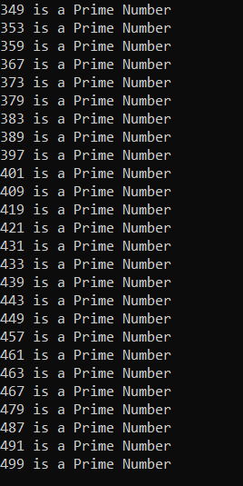

**Code:**

/*Task 8:

Write a program to enter any number and calculate its factorial using do-while.*/

int factorial, i = 1;

printf("Please Enter a Factorial Number ");

scanf("%d", &factorial);

int given = factorial;

factorial = 1;

do

{

    factorial *= i;

    i++;

} while (i <= given);

printf("Factorial of %d is %d", given, factorial);

**Output:**

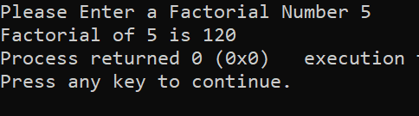

**Code:**

/*Task 9:

Write a C program to enter any number from user and find the reverse of number, the program executes once and if user wants to repeat the program he will press Y.

Example:

Input:1234

Output:4321*/

// From For loop

int num, r;

printf("Please Enter Number ");

scanf("%d", &num);

for (; num > 0;)

{

    r = num % 10;

    printf("%d", r);

    num /= 10;

}

// From While Loop

int num, r;

printf("Please Enter Number ");

scanf("%d", &num);

while (num > 0)

{

    r = num % 10;

    printf("%d", r);

    num /= 10;

}

// From Do While Loop

int num, r;

printf("Please Enter Number ");

scanf("%d", &num);

do

{

    r = num % 10;

    printf("%d", r);

    num /= 10;

} while (num > 0);

**Output:**

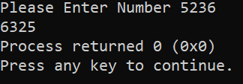

**Code:**

/*Task 10:

Write a do while loop which will produce the following output.

1

22

333

4444

55555*/

int num = 1;

int count = 1;

do

{

    int i = 1;

    do

    {

        printf("%d", num);

        i++;

    } while (i <= count);

    printf("\n");

    num++;

    count++;

} while (num <= 5);

**Output:**

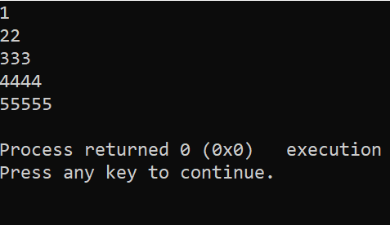

**-------------------------------------------------------------**

### LAB 09

**Code:**

//Task 01:  
 Write a program that will inert 10 int in array and print in new lines

    int arr[10], i;

    printf("Please Enter 10 Numbers \n");

    for (i = 0; i < 10; i++)

    {

        scanf("\n%d", &arr[i]);

        printf("\nvalue %d: %d\n", i + 1, arr[i]);

    }

**Output:**

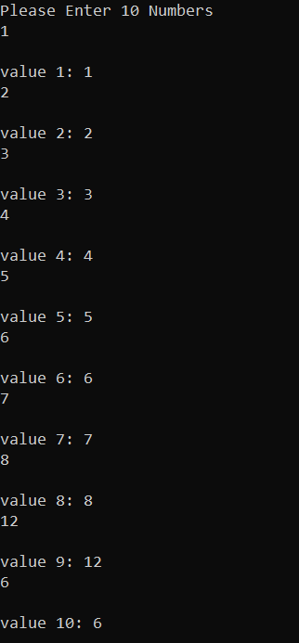

**Code:**

//Task 2:

Write a program that will ask user to input index number from where

to delete a number from array

    int arr[5], delete;

    printf("You have to input 5 values for array\n");

    for (int i = 0; i < 5; i++)

    {

        scanf("%d", &arr[i]);

    }

    printf("Array created successful");

    printf("\nPlease Enter which index do you want to delete");

    scanf("%d", &delete);

    arr[delete] = 0;

    for (int h = 0; h < 5; h++)

    {

        printf("%d", arr[h]);

    }

**Output:**

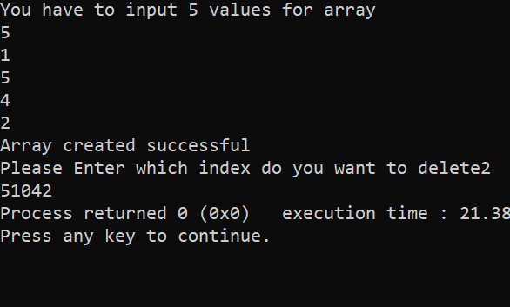

**Code:**

//Task 3:

Write a program that will find largest and smallest number from Array

    int a[5] = {1, 2, 5, 9, 3};

    int min, max;

    min = a[1];

    max = a[1];

    for (int i = 0; i < 5; i++)

    {

        if (min > a[i])

        {

            min = a[i];

        }

        if (max < a[i])

        {

            max = a[i];

        }

    }

    printf("Minimum %d", min);

    printf("Maximum %d", max);

**Output:**

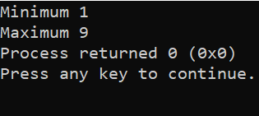

**Code:**

//Task 4:

Take 10 numbers from user in an array calculate the sum avg of those num

    int arr[10], sum = 0, i, avg;

    printf("Please Enter 10 Numbers \n");

    for (i = 0; i < 10; i++)

    {

        scanf("\n%d", &arr[i]);

        sum += arr[i];

    }

    avg = sum / i;

    printf("Average: %d\nSum: %d", avg, sum);

**Output:**

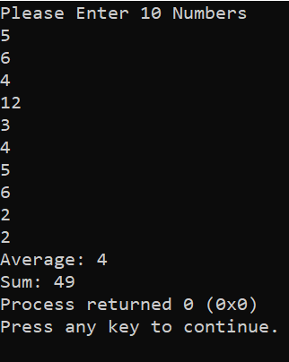

**Code:**

//Array Reverse

    /*Write a program to create two character arrays of same length and

    copy the content of one array into another in reverse order.*/

    char First[5] = {'H', 'A', 'M', 'Z', 'A'};

    char second[5];

    int i, j = 0, k;

    for (i = 4; i >= 0; i--)

    {

        printf(" %c", First[i]);

        second[j] = First[i];

        j++;

    }

    printf("\n");

    for (k = 0; k < 5; k++)

    {

        printf(" %c", second[k]);

    }

**Output:**

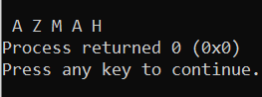

**Code:**

// Bubble Sorting

    // Ascending

    int arr[5] = {22, 9, 3, 5, 8};

    int temp, i, n;

    for (i = 0; i < 5; i++)

    {

        for (n = 0; n < 5; n++)

        {

            if (arr[n] < arr[n + 1])

            {

                temp = arr[n];

                arr[n] = arr[n + 1];

                arr[n + 1] = temp;

            }

        }

    }

    int h;

    for (h = 0; h < 5; h++)

    {

        printf("\n%d", arr[h]);

    }

**Output:**

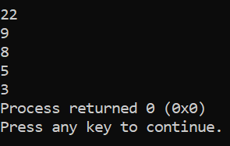

**Code:**

    // Bubble Sorting

    // Descending

    int arr[5] = {22, 9, 3, 5, 8};

    int temp, i, n;

    for (i = 0; i < 5; i++)

    {

        for (n = 0; n < 5; n++)

        {

            if (arr[n] > arr[n + 1])

            {

                temp = arr[n];

                arr[n] = arr[n + 1];

                arr[n + 1] = temp;

            }

        }

    }

    int h;

    for (h = 0; h < 5; h++)

    {

        printf("\n%d", arr[h]);

    }

**Output:**

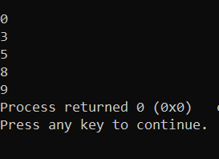

**-------------------------------------------------------------**

### LAB 10

**Code:**

/*Task 1:

   Write a program that accepts one string and then find the length of

That string and print it.*/

    char name[20];

    int length;

    printf("Please Enter Your Name: ");

    gets(name);

    printf("\nYour Name is ");

    puts(name);

    // Checking Length & Print Length

    length = strlen(name);

    printf("%d", length);

**Output:**

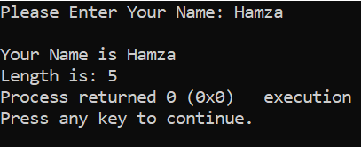

**Code:**

/*Task 2:

  Write a program that takes input in a string (char array) and ‘find’

a particular character and ‘replace’ that character. The program

should replace all the occurrences of that particular character with the

new character.

    For example:

    Array: “I love programming” find character: ‘m’

    replace with character: ‘n’

    then the string should become “I love progranning”*/

    char name[20];

    char old;

    char replace;

    printf("Please Enter Your Name: ");

    gets(name);

    printf("\nYour Name is ");

    puts(name);

    printf("What you want to replace? ");

    scanf("%c", &old);

    printf("Replace With? ");

    scanf("%c", &replace);

    for (int i = 0; i < strlen(name); i++)

    {

        if (name[i] == old)

        {

            name[i] = replace;

        }

    }

    puts(name);

**Output:**

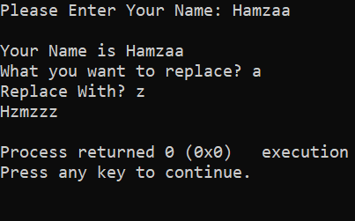

**Code:**

/*Task 3:

  Fifteen numbers are entered from the keyboard into an array with 3 rows

and 5 columns. The number to be searched is entered through the keyboard

by the user. Write a program to find if the number to be searched is

present in the array and if it is present, display the number of times

it appears in the array. */

    int arr[3][5];

    int i, j, value, count = 0;

    // Taking Value from User

    for (i = 0; i < 3; i++)

    {

        for (j = 0; j < 5; j++)

        {

            printf("Enter the number at array[%d][%d] ", i, j);

            scanf("%d", &arr[i][j]);

        }

    }

    // Search value

    printf("Please Enter number to be searched: ");

    scanf("%d", &value);

    // Count Search Value

    for (i = 0; i < 3; i++)

    {

        for (j = 0; j < 5; j++)

        {

            if (arr[i][j] == value)

            {

                count++;

            }

        }

    }

    printf("The number %d appeared %d times in Array ", value, count);

**Output:**

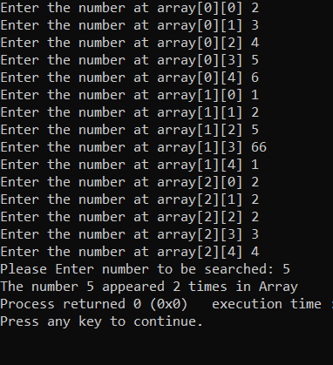

**Code:**

    /*Task 4:

    Write a program to pick up the largest number and sum of all the

integers from any 5 x 5 matrix. */

    int matrix[5][5], i, j;

    int largest = 0, sum = 0;

    // Taking Value from User

    for (i = 0; i < 5; i++)

    {

        for (j = 0; j < 5; j++)

        {

            printf("Enter the number at matrix[%d][%d] ", i, j);

            scanf("%d", &matrix[i][j]);

        }

    }

    // Largest Number

    for (i = 0; i < 5; i++)

    {

        for (j = 0; j < 5; j++)

        {

            if (matrix[i][j] > largest)

            {

                largest = matrix[i][j];

            }

        }

    }

    // Sum of Numbers

    for (i = 0; i < 5; i++)

    {

        for (j = 0; j < 5; j++)

        {

            sum += matrix[i][j];

        }

    }

    printf("\nLargest Number %d", largest);

    printf("\nSum %d", sum);

**Output:**

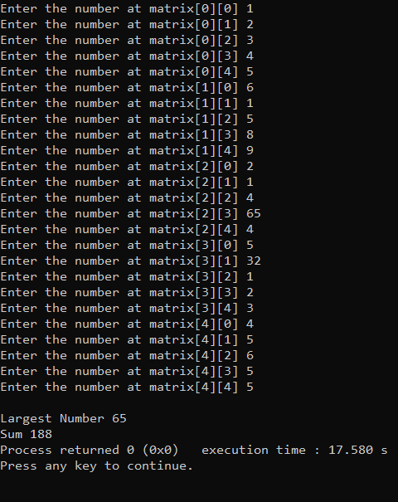

**Code:**

    /*Task 5:

   Write a program to obtain transpose of a 4x4 matrix. The transpose of

a matrix is obtained by exchanging the elements of each row with

the elements of the corresponding column*/

    int matrix[4][4];

    int transpose[4][4];

    int i, j;

    // Taking Value from User

    for (i = 0; i < 4; i++)

    {

        for (j = 0; j < 4; j++)

        {

            printf("Enter the number at matrix[%d][%d] ", i + 1, j + 1);

            scanf("%d", &matrix[i][j]);

        }

    }

    // Transpose of a Matrix

    for (i = 0; i < 4; i++)

    {

        for (j = 0; j < 4; j++)

        {

            transpose[j][i] = matrix[i][j];

        }

    }

    // Print Orignal Matrix

    printf("------Orignal Matrix-----\n");

    for (i = 0; i < 4; i++)

    {

        for (j = 0; j < 4; j++)

        {

            printf("  %d", matrix[i][j]);

        }

        printf("\n");

    }

    // Print Transpose of a Matrix

    printf("------Transpose of a Matrix-----\n");

    for (i = 0; i < 4; i++)

    {

        for (j = 0; j < 4; j++)

        {

            printf("  %d", transpose[i][j]);

        }

        printf("\n");

    }

**Output:**

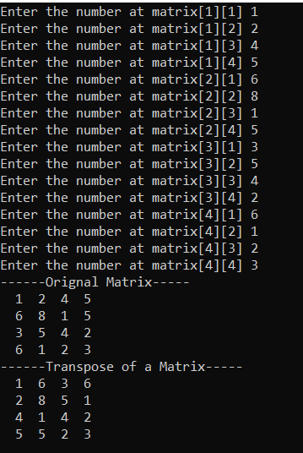

**Code:**

/*Task 6:

  Write a program to add two 6 x 6 matrices. Add result in third array

and print this array.*/

    int result[6][6],i,j;

    int firstMatrix[6][6] = {

        {1, 2, 3, 4, 5, 6},

        {2, 4, 6, 8, 9, 10},

        {3, 6, 9, 12, 15, 16},

        {4, 8, 12, 16, 19, 21},

        {5, 10, 15, 20, 25, 30},

        {2, 1, 3, 4, 5, 6} };

    int secondMatrix[6][6] = {

        {1, 2, 3, 4, 5, 6},

        {2, 3, 6, 8, 9, 1},

        {3, 4, 9, 2, 5, 6},

        {4, 5, 1, 6, 9, 1},

        {5, 6, 5, 0, 5, 0},

        {6, 7, 3, 4, 5, 6}

    };

    // Addition of two matrices

    for(i=0;i<6;i++){

        for(j=0;j<6;j++){

            result[i][j]=firstMatrix[i][j]+secondMatrix[i][j];

        }

    }

    // Print Addition

    for(i=0;i<6;i++){

        for(j=0;j<6;j++){

           printf("%d",result[i][j]);

        }

        printf("\n");

    }

**Output:**

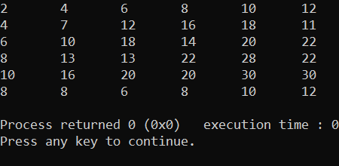

**Code:**

 /*Task 7:

  Write a program to multiply any two 3 x 3 matrices. Add result in

third array and print this array.*/

    int result[3][3],i,j;

    int firstMatrix[3][3] = {

        {1, 2, 3},

        {2, 4, 6},

        {3, 6, 9}

    };

    int secondMatrix[3][3] = {

        {1, 2, 3},

        {2, 3, 6},

        {3, 4, 9}

    };

    // Multiplication of two matrices

    for(i=0;i<3;i++){

        for(j=0;j<3;j++){

              result[i][j]=0;

            for(int k=0;k<3;k++){

                result[i][j] += firstMatrix[i][k]*secondMatrix[k][j];

            }

        }

    }

    // Print Multiplication

    for(i=0;i<3;i++){

        for(j=0;j<3;j++){

           printf("%d",result[i][j]);

        }

        printf("\n");

    }

**Output:**

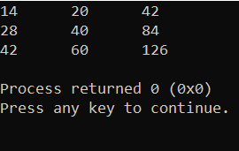

**Code:**

   /*Task 8:

   In a bitmap file black is represented by 1 and white by 0. Create a

8X8 pattern and initialize using following data:

    1 1 1 0 0 1 1 1

    1 0 0 0 0 0 1 0

    1 1 1 1 1 1 0 0

    1 1 1 0 0 0 1 0

    1 0 1 0 1 0 1 0

    0 0 0 0 0 0 0 0

    1 1 1 1 1 1 1 1

    0 0 0 0 1 1 1 1 */

    int bitmapPattern[8][8]={

        {1,1,1,0,0,1,1,1},

        {1,0,0,0,0,0,1,0},

        {1,1,1,1,1,1,0,0},

        {1,1,1,0,0,0,1,0},

        {1,0,1,0,1,0,1,0},

        {0,0,0,0,0,0,0,0},

        {1,1,1,1,1,1,1,1},

        {0,0,0,0,1,1,1,1}

    };

    int i,j;

    for(i=0;i<8;i++){

        for(j=0;j<8;j++){

            printf("%d  ",bitmapPattern[i][j]);

        }

        printf("\n");

    }

**Output:**

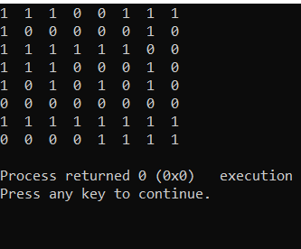

**-------------------------------------------------------------**

### LAB 11

**Code:**

/*Task 1:

Write a function to calculate the factorial value of any integer entered through the keyboard*/

#include <stdio.h>

#include <stdlib.h>

int facto(int n)

{

    if (n == 0)

    {

        return 1;

    }

    else

    {

        return n * facto(n - 1);

    }

}

int main()

{

    int n, fact;

    printf("Please Enter Factorial no: ");

    scanf("%d", &n);

    fact = facto(n);

    printf("Factorial of %d is %d", n, fact);

    return 0;

}

**Output:**

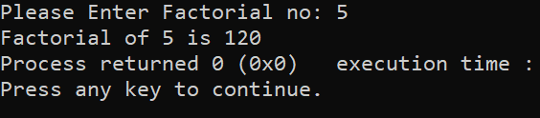

**Code:**

/*Task 2:

Write a function power (a, b) to calculate the value of ‘a’ raised to the power of ‘b’.*/

#include <stdio.h>

#include <stdlib.h>

int power(int a, int b)

{

    if (b == 0)

    {

        return 1;

    }

    else if (b == 1)

    {

        return a;

    }

    else

    {

        return a * power(a, b - 1);

    }

}

int main()

{

    int a, b;

    printf("Enter the base: ");

    scanf("%d", &a);

    printf("Enter the exponent: ");

    scanf("%d", &b);

    int value = power(a, b);

    printf("The value of %d raised to the power of %d is %d\n", a, b, value);

    return 0;

}

**Output:**

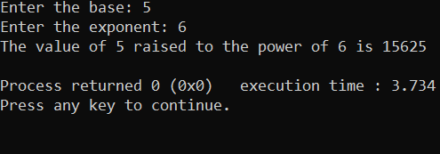

**Code:**

/*Task 3:\

Write a general-purpose function to convert any given year into its roman equivalent. The following table shows the roman equivalents of decimal numbers:

Decimal          Roman

1                   i

100                 c

5                   v

500                 d

10                  x

1000                m

50                  l

Example:

Roman equivalent of 1988 is mdcccclxxxviii

Roman equivalent of 1525 is mdxxv */

#include <stdio.h>

#include <stdlib.h>

void convertRoman(int Convertyear)

{

    while (Convertyear)

    {

        if (Convertyear >= 1000)

        {

            printf("M");

            Convertyear = Convertyear - 1000;

        }

        else if (Convertyear >= 500)

        {

            printf("D");

            Convertyear = Convertyear - 500;

        }

        else if (Convertyear >= 100)

        {

            printf("C");

            Convertyear = Convertyear - 100;

        }

        else if (Convertyear >= 50)

        {

            printf("L");

            Convertyear = Convertyear - 50;

        }

        else if (Convertyear >= 10)

        {

            printf("X");

            Convertyear = Convertyear - 10;

        }

        else if (Convertyear >= 5)

        {

            printf("V");

            Convertyear = Convertyear - 50;

        }

        else if (Convertyear >= 1)

        {

            printf("I");

            Convertyear = Convertyear - 1;

        }

    }

}

int main()

{

    int year;

    printf("Convert Year into Roman");

    // Taking Year from User

    printf("Please Enter a Year ");

    scanf("%d", &year);

    convertRoman(year);

    return 0;

}

**Output:**

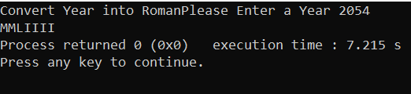

**-------------------------------------------------------------**

### LAB 12

**Code:**

/*Task 1:

There is a structure called employee that holds information like employee code, name, date of joining. Write a program to create an array of the structure and enter some data into it. Then ask the user to enter current date. Display the names of those employees whose tenure is 3 or more than 3 years according to the given current date. */

#include <stdio.h>

#include <string.h>

struct Employee {

    int EmpCode;

    char name[50];

    int YearofJoining;

} employeeData[2];

int main() {

    int currentYear;

    // Taking Employee data

    for (int i = 0; i < 2; i++) {

        // Clear the input buffer before reading the employee name

        while (getchar() != '\n');

        printf("======= Employee %d =======",i+1);

        printf("\nPlease Enter an Employee code: ");

        scanf("%d", &employeeData[i].EmpCode);

        printf("Please Enter Employee Name: ");

        fgets(employeeData[i].name,50,stdin);

        employeeData[i].name[strlen(employeeData[i].name)-1]=0;

        printf("Please Enter the Year of Joining: ");

        scanf("%d", &employeeData[i].YearofJoining);

        printf("\n");

    }

    system("cls");

    printf("Enter Current Year: ");

    scanf("%d",&currentYear);

    printf("Employee with tenure 3 or more \n");

    for(int i=0;i<2;i++){

        int tenure = currentYear - employeeData[i].YearofJoining;

        if(tenure >= 3){

            printf("Name: %s \n",employeeData[i].name);

            printf("Year of Joining: %d \n",employeeData[i].YearofJoining);

            printf("\n");

        }

    }

    return 0;

}

**Output:**

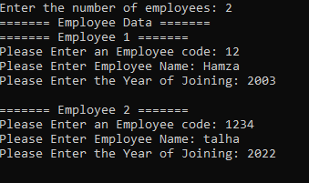

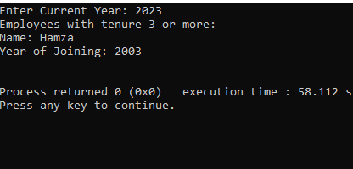

**-------------------------------------------------------------**

### Structures(Book Questions)

**Code:**

//Define a structure consisting of two floating-point members, called real & imaginary. Include the tag complex within the definition

    struct complex{

    float real;

    float imaginary;

    };

**Code:**

//Declare the variable x1,x2,x3 to be structures of type complex as describe in the program

struct complex x1,x2,x3;

x2.real = 20.5;

printf("%f",x2.real);

**Code:**

//Combine Upper Both Question

struct complex{

    float real;

    float imaginary;

    }x1,x2,x3;

**Code:**

//Declare a structure variable x and assign a value 1.3 , -2.2 in real & imaginary

struct complex x;

   x.real =1.3;

   x.imaginary = -2.2;

printf("%f,%f",x.real,x.imaginary);

**Code:**

    // Declare a one dimensional 100 element array called cx whose elements are structure of type complex,

    struct complex cx[100];

**Code:**

    // Combine the structure definition and the array declaration

    struct complex

    {

        float real;

        float imaginary;

    } cx[100];

**Code:**

/*Define a structure that contains the following three members

    --> an int called won

    --> an int called lost

    --> an float called percentage

    Include the user-defined data type record within the definition

    */

    struct record

    {

        int won;

        int lost;

        float percentage;

    };

**Code:**

/*Define a structure that contain the following two members

    --> a 40-element character called name

    --> a structure name stats,of type record

    Include the user-defined data type team within the definition */

    struct team

    {

        char name[40];

        struct record stats;

    };

**Code:**

/*Declare a t to be a structure variable of type team as in the previous problem Write a expression of each member & submember of t.*/

    struct record

    {

        int won;

        int lost;

        float percentage;

    };

    struct team

    {

        char name[40];

        struct record stats;

    } t;

    t.stats.won = 2;

    printf("%d", t.stats.won);

**Code:**

   /*Declare a t to be a structure variable of type team as in the

    previous problem.Initialize t as follows:

    name: Chichago Bears

    won:14

    lost:2

    percentage:87.5

    */

    struct record

    {

        int won;

        int lost;

        float percentage;

    };

    struct team

    {

        char name[40];

        struct record stats;

    } t;

    t.name = "Hamza Kamelen";

    t.stats.won = 14;

    t.stats.lost = 2;

    t.stats.percentage = 87.5;

    return 0;

}

**-------------------------------------------------------------**

### Pointers(Book Questions)

**Code:**

/*Q1:

Write a function that recieve 5 integer & returns the sum,avg & standard deviation of these numbers. Call this function from main() and print the result in main()*/

void Values(int numbers[5],int size,int *sum,float *avg,float *var,float *std){

    *sum=0;

    for(int i=0;i<size;i++){

        *sum+= numbers[i];

    }

    *avg = *sum/size;

    for(int i=0;i<size;i++){

        *var += ((numbers[i]-*avg)*(numbers[i]-*avg));

    }

    *var = *var/size;

    *std = sqrt(*var);

}

int main(){

    int numbers[5];

    int sum;

    float avg;

    float var;

    float std;

    for(int i=0;i<5;i++){

        printf("Please Write %d Number ",i+1);

        scanf("%d",&numbers[i]);

    }

    Values(numbers,5,&sum,&avg,&var,&std);

    printf("\nSum: %d",sum);

    printf("\nAverage: %.2f",avg);

    printf("\nStandard Deviation: %.2f",std);

return 0;

}

**Code:**

/*Q2:

Write a function that recieve marks recieved by a student in 3 subjects & returns the percentage,avg of these numbers. Call this function from main() and print the result in main()*/

void DateSheet(int *marks,int size,int *total,float *avg,float *perc){

    *total=0;

    for(int i=0;i<size;i++){

        *total += marks[i];

    }

    *avg = *total/size;

    *perc = (*total *100)/(size*100);

}

int main(){

    int marks[3];

    int total=0;

    float avg=0;

    float perc;

    marks[3]=0;

    for(int i=0;i<3;i++){

        printf("Marks of %d Subject ",i+1);

        scanf("%d",&marks[i]);

    }

    DateSheet(marks,3,&total,&avg,&perc);

    printf("\nObtained Marks: %d",total);

    printf("\nAverage: %.2f",avg);

    printf("\nPercentage: %.2f",perc);

return 0;

}

**Code:**

/*Q3:

Given three variable x,y,z write a function to circularly shift their values to right. In other words if x=5,

y=8,z=10 after circular shift y=5, z=8, x=10.Call the function with variable a,b,c to circular shift values*/

void CircularShift(int *x,int *y,int *z){

int temp = *x;

*x =*z;

*z =*y;

*y = temp;

}

int main(){

    int x=5,y=8,z=10;

    CircularShift(&x,&y,&z);

    printf("%d %d %d",x,y,z);

return 0;

}

**-------------------------------------------------------------**